**PROJECT SYNOPSIS**

**“Softpro Online Test Portal”**

SYNOPSIS SUBMITTED FOR THE PARTIAL FULFILMENT OF THE

REQUIREMENT FOR THE THREE-YEAR BACHELOR IN

**“Computer Science/Information Technology”**

**SUBMITTED TO**

**“Dr. Ram Manohar Lohia Avadh University”**

**Ayodhya**

**SUBMITTED BY:**

**Avnish Tiwari**

**ROLL NO:**

**“20220001957331”**

**(College Enrolment Number- 22000244)**

**2022-2025**



**Under the Guidance of**

Er. Brijesh Mishra

Senior Consultant

**ABOUT THE ORGANISATION**

Softpro India Computer Technologies (P) Ltd. is a leading IT firm and the software development division of Softpro Group of Companies with its headquarter located in the capital city of Uttar Pradesh, Lucknow. Softpro India was established in 2004 by technocrats from IIT-Kanpur and IET Lucknow. Softpro Group of Companies is a cluster of companies working in multiple domains like Software Development, IT Trainings, Research and Designing. The Founder and Managing Director of Softpro Group of Companies is Er. Ajay Chaudhary with over 25 years of experience. Softpro India is the fastest growing IT company with the largest learning center of the region having experienced consultants of 15+ years and industry experts.

Softpro Group of Companies compromises of Softpro Learning Center (Training & Internship division – 2008), Softpro Innovations (R&D division – 2014) and Softpro Foods (Agro Production division – 2018). Softpro India has global presence with its Head Office and Training Center located in Lucknow, International Unit Office located in Malawi, Africa and Virtual Office located in Kuala Lumpur, Malaysia. Softpro India has successfully delivered Government Projects like the visionary project of Government of Uttar Pradesh – *URISE.* Softpro India also has signed MoU with Department of Technical Education, Government of Uttar Pradesh making it the authorised Training & Development partners to impart and technically upskill all the engineering students of polytechnics (government, private & aided) across Uttar Pradesh.

Softpro India’s recent achievements include the MoU signing with Dr. A. P. J. Abdul Kalam Technical University, Uttar Pradesh. Technologies are transcending boundaries and their volatility is putting stringent demands on the time and mind-space of techno-professionals. At SPG, we update ourselves with technologies even before they become norms and master them long before they become redundant. That's why we are on the roster of clients from across the continents.

Softpro India offers training for all the ranches of engineering (Computer Science, Information Technology, Electronics, Electrical, Civil, Mechanical) for updated and trending technologies. Softpro India also has several online and offline trainings like Summer Training, Industrial Training, Vocational Training, Apprenticeship Program, Employment Training Program and Online Courses. The learning material and other resources are available on Softpro India’s Learning Management System (LMS) – “Polyprep – Knowledge @ Your Doorstep” and mobile application – “e-Study Zone”.

Come to think of it, we have engineered ourselves to be at the very forefront in Web based technology. Our core competencies span a spectrum of web-intensive services that range from website designing to robust backend management.

**About BTEUP**

State Board of Technical Education and Training was set up in the state in May,1958. The Board conducted its first examination in 1960, for courses of diploma level and also for Draughtsman Certificate Course. The name of the state Board was changed to Board of Technical Education in 1962. In the same Year, the U.P. Pravidhic Shiksha Adhiniyam - 1962 was enacted awarding the Board statutory status. In the year 1962, year of its inception, the Board held the examination of about 2500 students, in three major disciplines of Civil, Electrical and Mechanical Engineering at 25 different Centers/Institutions. It has a chairman, vice-chairman and 40 members, named by the state government. Secretary, Board of Technical Education, U.P. is ex-officio member secretary of the Board. The curriculum prepared by other institutions was adopted by the Board, till 1980 but thereafter the curriculum and syllabi were developed and revised, every five years at the Board level through its Curriculum development cell. The curriculum development work has been entrusted to I.R.D.T. Kanpur. The Board now examine and approve the syllabus developed by IRDT, Kanpur and prescribe it for institutions affiliated to Board of Technical Education, U.P. About 1,05,000 students in the 60 different disciplines of one year, two year, three year and four year durations are being examined at present, in the institutions, affiliated to the Board. The Board of has been constituted under U.P. Pravidhic Shiksha Adhiniyam - 1962. It has a Chairman and a Vice-Chairman and, 40 memebers nominated by the state Government. Secretary, Board of Technical Education is ex-officio member secretary of the Board.

**SUMMER TRAINING**

Summer training is an important part of the engineering curriculum. The summer training helps a student in getting acquainted with the manner in which his/her knowledge is being practically used outside his/her institute and this is normally different from what he/she has learnt from books. Hence, when the student switches from the process of learning to that of implementing his/her knowledge, he/she finds an abrupt change. This is exactly why summer training session during the **B.T.E** curriculum becomes all the more important. Summer training is prescribed for the student of Technical College as a part of the four-year degree course of engineering by the AICTE. We are required to undergo summer training for a period of 45 days after the completion of the 2nd year.

Summer Training allows industry exposure and understanding the working environment & it gives the industrial exposure. It is essential and helps to attain in-depth knowledge of the engineering stream. It enhances professional skills in a real-time environment. It helps us understand the area of interest and selection of an area of specialization. It also allows students to learn the basics of how to work as a team member to complete given tasks. It improves awareness of the industrial environment and work culture of the specific industry. It gives real-time work and the projects help to learn more analytically. It allows interaction with experts to solve queries with practical exposure. The Certificate obtained from reputed organization give weightage to resume or CV.

**TECHNOLOGIES TRAINED ON DURING SUMMER TRAINING**

* **HTML: -** HTML is stand for hypertext markup language, this markup language is used to design static web pages. HTML contain pre-defined tags, which are useful to design web pages. HTML describes the structure of a Web page. HTML consists of a series of elements. HTML elements tell the browser how to display the content. HTML elements label pieces of content such as "this is a heading", "this is a paragraph", "this is a link", etc.
* **CSS: -** CSS stands for Cascading Style Sheets. CSS describes how HTML elements are to be displayed on screen, paper, or in other media.CSS is the language we use to style an HTML document. CSS describes how HTML elements should be displayed. CSS saves a lot of work. It can control the layout of multiple web pages all at once. External stylesheets are stored in CSS files.
* **Javascript: -** JavaScript is a scripting or programming language that allows you to implement complex features on web pages — every time a web page does more than just sit there and display static information for you to look at — displaying timely content updates, interactive maps, animated 2D/3D graphics, scrolling video jukeboxes, etc. — you can bet that JavaScript is probably involved. It is the third layer of the layer cake of standard web technologies, two of which (HTML and CSS).
* **Bootstrap: -** Bootstrap is the most popular HTML, CSS and JavaScript framework for developing a responsive and mobile friendly website. It is absolutely free to download and use. It is a front-end framework used for easier and faster web development. It includes HTML and CSS based design templates for typography, forms, buttons, tables, navigation, modals, image carousels and many others.It can also use JavaScript plug-ins. It facilitates you to create responsive designs.
* **Database: -** A database is an organized collection of data, so that it can be easily accessed and managed. You can organize data into tables, rows, columns, and index it to make it easier to find relevant information. Database handlers create a database in such a way that only one set of software program provides access of data to all the users. The main purpose of the database is to operate a large amount of information by storing, retrieving, and managing data.There are many dynamic websites on the World Wide Web nowadays which are handled through databases. For example, a model that checks the availability of rooms in a hotel. It is an example of a dynamic website that uses a database. There are many databases available like MySQL, Sybase, Oracle, MongoDB, Informix, PostgreSQL, SQL Server, etc.
* **Java: -** Java is an open source, object oriented, high level programming language. Java is a general-purpose programming language. By using java language, you can develop different kinds of applications like desktop applications, web applications, mobile applications, ERP, etc. In project development we use java as main programming language. In this internship program we develop a web-based application named “**Softpro Online Test Portal**”, In this web application we used Java with spring boot framework.
* **Spring Boot Framework: -** Spring is widely used for creating scalable applications. For web applications Spring provides Spring MVC which is a widely used module of spring which is used to create scalable web applications. But main disadvantage of spring projects is that configuration is really time-consuming and can be a bit overwhelming for the new developers. Making the application production-ready takes some time if you are new to the spring. Solution to this is Spring Boot. Spring Boot is built on the top of the spring and contains all the features of spring. And is becoming favourite of developer’s these days because of it’s a rapid production-ready environment which enables the developers to directly focus on the logic instead of struggling with the configuration and set up. Spring Boot is a microservice-based framework and making a production-ready application in it takes very less time.

**About Client: Softpro India**

Softpro India Computer Technologies (P) Ltd. is a leading IT firm and the software development division of Softpro Group of Companies with its headquarter located in the capital city of Uttar Pradesh, Lucknow. Softpro India was established in 2004 by technocrats from IIT-Kanpur and IET Lucknow. Softpro Group of Companies is a cluster of companies working in multiple domains like Software Development, IT Trainings, Research and Designing. The Founder and Managing Director of Softpro Group of Companies is Er. Ajay Chaudhary with over 25 years of experience. Softpro India is the fastest growing IT company with the largest learning center of the region having experienced consultants of 15+ years and industry experts.

**Objective**

An online test portal serves several key objectives, each aimed at enhancing the efficiency and effectiveness of the assessment process. Here are the main goals:

1. **Accessibility**: Provides easy access to tests from anywhere with an internet connection, accommodating a wide range of users.
2. **Convenience**: Allows users to take tests at their convenience, eliminating the need for physical test centers and rigid scheduling.
3. **Efficiency**: Streamlines the administration, management, and scoring of tests, reducing the time and resources needed compared to traditional methods.
4. **Scalability**: Supports large numbers of users and tests simultaneously, making it suitable for educational institutions, certification bodies, and organizations of all sizes.
5. **Flexibility**: Offers various types of questions (multiple choice, essay, true/false, etc.), and can be customized to meet specific assessment needs.
6. **Instant Feedback**: Provides immediate feedback and results to users, which can aid in learning and improvement.
7. **Data Management**: Collects and manages test data efficiently, including scores, user progress, and historical data for analysis and reporting.
8. **Security**: Ensures the integrity of the test process through secure access controls, anti-cheating mechanisms, and data protection measures.
9. **Cost-effectiveness**: Reduces the costs associated with printing, distribution, and manual grading of tests.
10. **Analytics**: Offers tools for analyzing test performance, trends, and other metrics, which can inform educational strategies and decision-making.

Overall, an online test portal aims to modernize and optimize the assessment experience for both administrators and users.

**ABOUT THE PROJECT**

This Project is an online test portal. The analysis steps of project are given below: -

* **Feasibility Study**

Feasibility study is the measure of how beneficial or practical the development of an information system will be to an organization. The Feasibility analysis is a cross life cycle activity and should be continuously performed throughout the system life cycle.

* **Operational Feasibility: -**

By providing the web-based application, all the users will get a very good facility of accessing the service to fulfil their requirements. All the user information, information sharing and selection process is done properly.

Users will feel comfortable by reduction of their work. The system will make handling of large databases easy. Losing of records will be avoided. Considering all these factors, we can conclude that all the users and end users will be satisfied by the system.

* **Technical Feasibility: -**

For the design and development of the system, several software products have been accommodated.

* Database design – MySQL
* Interface design – HTML, CSS, Java Script and Bootstrap.
* Coding – Java with Spring Boot Framework

The technology (Java with Spring Boot Framework) has enough efficiency for the development of the system. Therefore, the project is technically feasible.

* **Schedule Feasibility: -**

The duration of time required for the project has been planned appropriately and it is the same as the duration of time expected by the client. Therefore, the application can be delivered to the client within the expected time duration, satisfying the client. Hence the project is feasible in scheduling.

* **Economic Feasibility: -**

According to the resources available and the project scheduling process it is estimated that the expenses allocated for the web application to be developed, by the client is sufficient enough. Hence the economical factor has been considered feasible.

* **Project Planning & Scheduling: -**

Planning is very important part of any software development. In the planning phase we decide which features are to be included in the system to make a good system, how much time do we need to complete the project, what will the cost of the system etc…

A Software Life Cycle or software process is a series of identifiable stages that a software product undergoes during its development. A software product development effort usually starts with a project identification and selection stage and then requirements analysis; design, coding, testing, implementation and maintenance are undertaken.

A life cycle model identifies all the activities required to develop and maintain a software product and establishes a precedence ordering among the different activities.

The various phases of Software Development Life Cycle-

* Requirement Analysis
* System Design
* Coding
* Testing
* Implementation

**SOFTWARE REQUIREMENTS FOR DEVELOPMENT**

|  |  |
| --- | --- |
| User Interface Designing | HTML5, CSS3, Java Script, Bootstrap |
| Programming Language | Java with Spring Boot Framework |
| Database | MySQL |
| IDE | STS (Spring Tool Suit) |

**High Level Design**

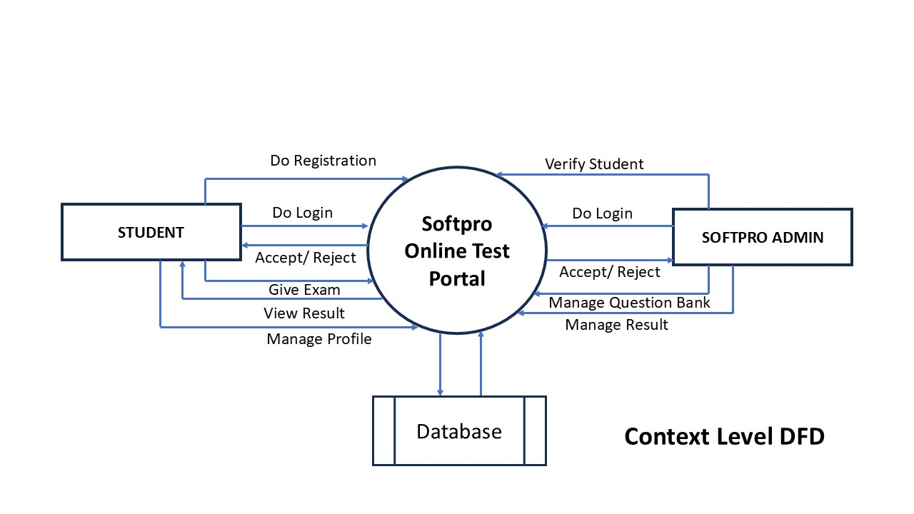

**Low Level Designing**

**Database Designing**

**Database Name: - oesdb**

Table Name: studentinfo

|  |  |
| --- | --- |
| Column Name | Data Type |
| Rollno | int primary key |
| Name | varchar(50) |
| Fname | varchar(50) |
| Mname | varchar(50) |
| Gender | varchar(6) |
| Address | varchar(1000) |
| Program | varchar(100) |
| Branch | varchar(100) |
| Year | varchar(100) |
| Contactno | varchar(10) |
| Emailaddress | varchar(50) |
| Regdate | varchar(30) |

Table Name: login

|  |  |
| --- | --- |
| Column Name | Data Type |
| Userid | varchar(50) primary key |
| Password | varchar(20) |
| Usertype | varchar(50) |
| Status | varchar(5) |

Table Name: enquiry

|  |  |
| --- | --- |
| Column Name | Data Type |
| id | int primary key auto_increment |
| name | varchar(50) |
| gender | varchar(6) |
| address | varchar(100) |
| contactno | varchar(10) |
| emailaddress | varchar(50) |
| enquirytext | varchar(1000) |
| enquirydate | varchar(30) |

Table Name: news

|  |  |
| --- | --- |
| Column Name | Data Type |
| id | int primary key auto_increment |
| newstext | varchar(1000) |
| posteddate | varchar(30) |

Table Name: course

|  |  |
| --- | --- |
| Column Name | Data Type |
| id | int primary key auto_increment |
| coursename | varchar(100) |

Table Name: qb

|  |  |
| --- | --- |
| Column Name | Data Type |
| qid | int primary key auto_increment |
| coursename | varchar(100) |
| question | varchar(1000) |
| opt1 | varchar(500) |
| opt2 | varchar(500) |
| opt3 | varchar(500) |
| opt4 | varchar(500) |
| correct | varchar(500) |

Table Name: result

|  |  |
| --- | --- |
| Column Name | Data Type |
| id | int primary key auto_increment |
| rollno | Int |
| coursename | varchar(100) |
| totalmark | Int |
| getmark | Int |
| examdate | varchar(30) |

**Modules in Project**

There are following modules in this project: -

* Student Information System
* Login Management System
* Enquiry Management System
* News Management
* Course Management
* Question Bank Management
* Examination Management
* Result Management
* Credential Management
* SMS API Integration

**Modules Description**

**Student Information System: -** This module contains information of students with given fields like rollno, name, program, branch, year etc.

**Login Management System: -** This module validates user login. It also tracks user after identification of user whether he/she is admin or student.

**News Management: -** Through this module, admin can post news, which are displayed on notice board.

**Enquiry Management: -** Through this module, any user can raise enquiry which are displayed on admin zone.

**Course Management: -** In this module, admin can manage courses offered by Nalanda Open University.

**Question Bank Management: -** Through this module, admin can make and manage question bank for online examination.

**Examination Management System: -** Through this module student and give examination for different subjects.

**Result Management: -** Through this module, student can view he/ she result after examination.

**Credential Management: -** This module, is responsible for manage credential of student.

**SMS API Integration: -** Through this module, a system generated SMS is send on user mobile after successful enquiry.

**Future Scope of Project**

The system is flexible enough to ensure well-coordinated efforts to face the strategic challenges emerging from rapidly changing economic environment and global trends. Facilities have been incorporated in the software so that online processing can be done easily and thus the effort and time can be saved.

* In future it is planned to develop our own web server to host the web application.
* Building Android Application for the system is also one of the future scopes of this project.